Social Media Post

Full version

Be part of the Global Pride Survey – a global project on the aging, health and service needs of sexual and gender minorities!

Are you a LGBTQ (lesbian, gay, bisexual, transgender, queer, non-binary, or sexual or gender diverse) adult aged 18 years or older?

GlobalPrideStudy.org

Complete a confidential and anonymous questionnaire and enter a prize draw awarding a gift box featuring Pacific Northwest favourites to 10 randomly selected individuals.

Help us spread the word! GlobalPride@uw.edu

Short version

Be part of the Global Pride Study - a ground-breaking, global project on the aging, health and service needs of LGBTQ+ adults aged 18 and older! Complete a confidential questionnaire and enter a prize draw for a gift box featuring Pacific Northwest favourites.

GlobalPrideStudy.org

GlobalPride@uw.edu

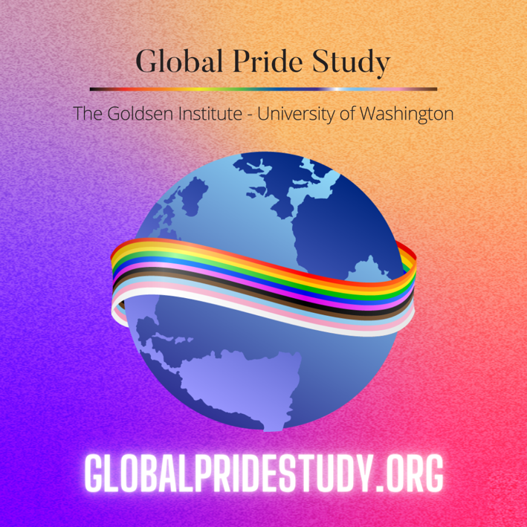
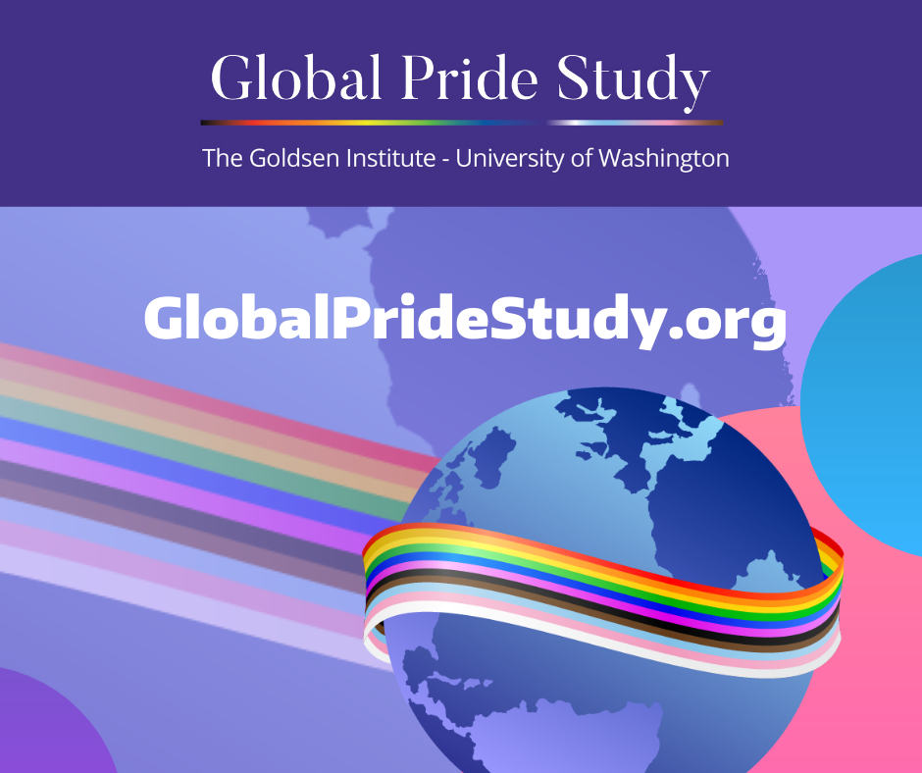
Image to use on Instagram Image to use on Facebook and Twitter

