Social Media Post (US English)

Full version

Be part of the Global Pride Survey!

Are you a LGBTQ (lesbian, gay, bisexual, takatāpui, transgender, queer, non-binary, or sexual or gender diverse) adult aged 18 years or older?
GlobalPrideStudy.org

Collaboration of more than 40 partners around the globe.
.
Complete a confidential and anonymous questionnaire and enter a drawing awarding a gift box featuring Pacific Northwest (US) favourites to 10 randomly selected individuals.

Help us spread the word! GlobalPride@uw.edu

Short version

Be part of the Global Pride Study!

Complete a confidential questionnaire and enter a prize draw for a gift box featuring Pacific Northwest (US) favourites.

GlobalPrideStudy.org

GlobalPride@uw.edu

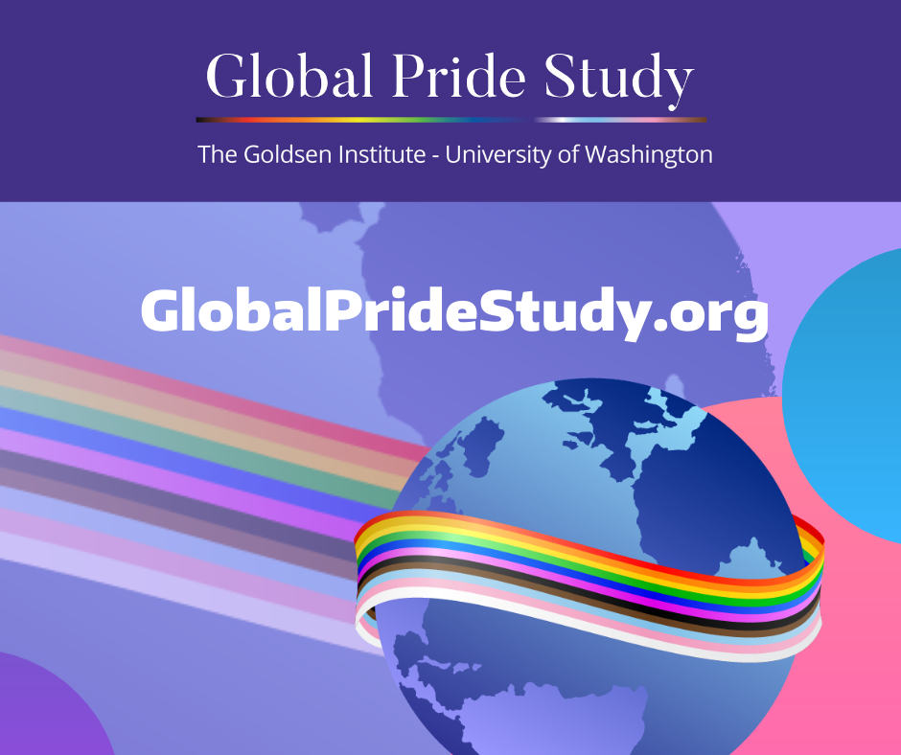
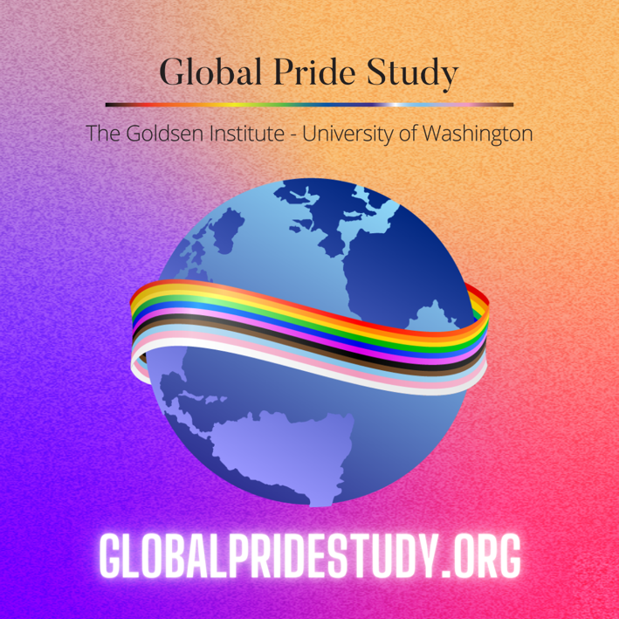
Image to use on Instagram Image to use on Facebook and Twitter

