Social Media Post (US English)
Full version
Be part of the Global Pride Survey!
Are you a 2SLGBTQ (Two-Spirit, lesbian, gay, bisexual, transgender, queer, non-binary, or sexual or gender diverse) adult aged 18 years or older?
GlobalPrideStudy.org

Collaboration of more than 40 partners around the globe.
Complete a confidential and anonymous questionnaire and enter a drawing awarding a gift box featuring Pacific Northwest favorites to 10 randomly selected individuals.
Help us spread the word!
GlobalPride@uw.edu
Short version
Be part of the Global Pride Study!
Complete a confidential questionnaire and enter a drawing for a gift box featuring Pacific Northwest favorites.
GlobalPrideStudy.org

GlobalPride@uw.edu

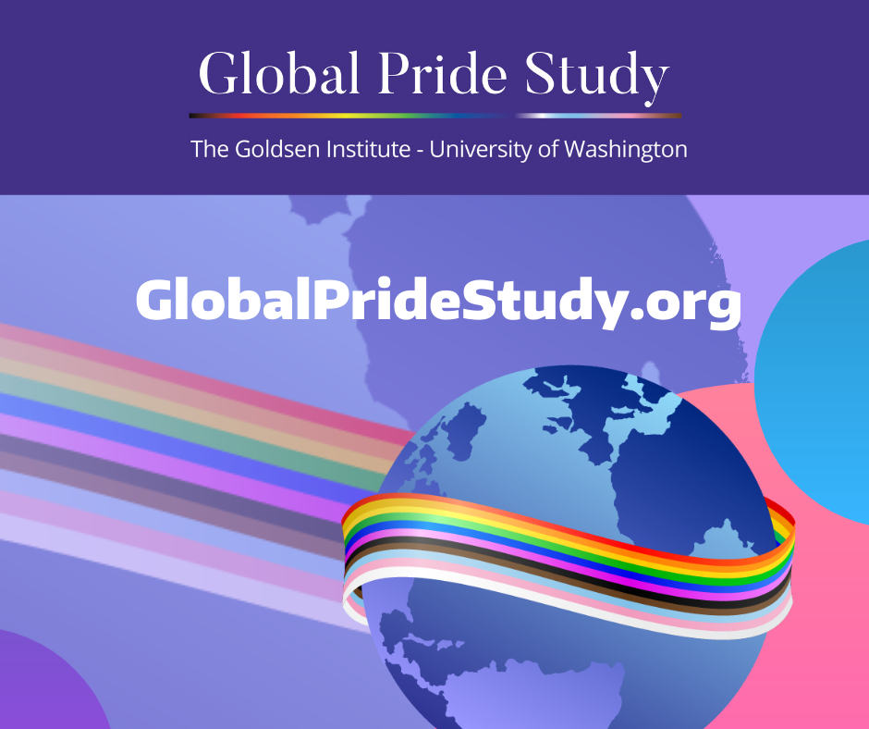
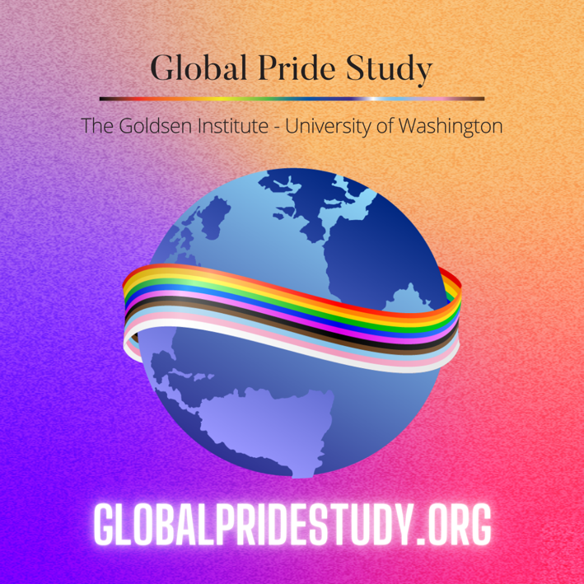
Image to use on Instagram Image to use on Facebook and Twitter

