Kafofin Watsa Labarai na Zamani (Turanci na Amurka)

Cikakken fasali

Kasance cikin Binciken Alfahari na Duniya!

Haɗin gwiwar abokan hulɗa sama da 40 a duniya.

GlobalPrideStudy.org
Kammala tambayoyin sirri da titafin tambayoyi na sirri kuma shigar da gasa na akwatin kyauta mai dauke da abubuwa da aka fi so daga Pacific Northwest zuwa 10 zaɓaɓɓun mutane.

Taimaka mu yada kalmar! GlobalPride@uw.edu

Shafi Gajere

Kasance cikin Binciken Alfahari na Duniya!

Kammala tambayoyin sirri kuma shigar gasar don akwatin kyauta wanda ke ƙunshe da abubuwa da aka fi so a Pacific Northwest.

GlobalPrideStudy.org

GlobalPride@uw.edu

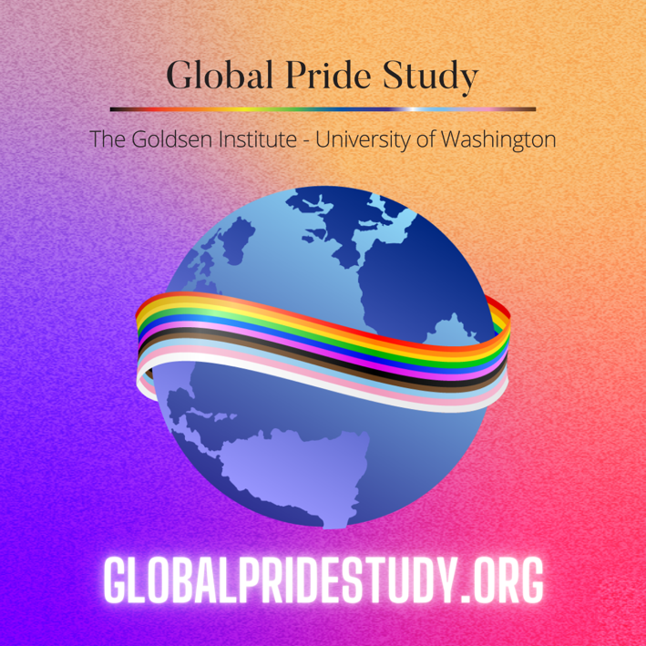
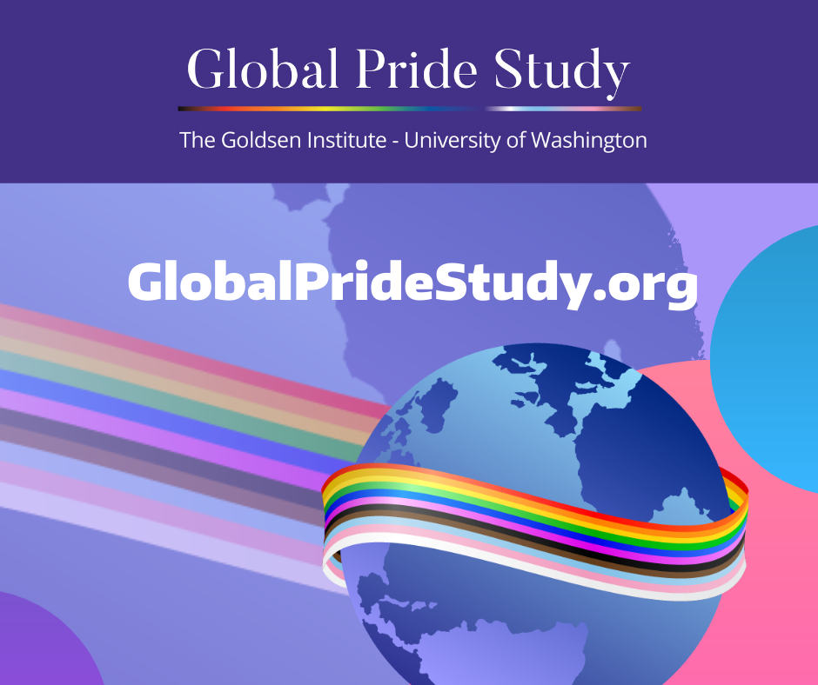
Use for Instagram: Use for Facebook and Twitter:

